

|  |  |
| --- | --- |
|  | Combined Year Project (Group 4) PHASE 3 (Execution and closing Phase) |
|  |  |
|  | Marco ID: 0001175063088 Email: 4861@ctucareer.co.za  MCSD Foundation_ICAS:  10/2/19 |

Table of Contents

Introduction: 2

Body: 3

• SQL Code for creating a database: 3

• Tables with attributes created in the database: 3

• Connect.php code provided: 5

Group: 6

Conclusion: 6

Reference: 6

# Introduction:

In Groups consisting of members representing various learning programs at CTU, students are required to plan, develop and execute an integrated project. CTU Construction Solutions is a newly established business that won its first tender to plan luxury accommodation on the east coast of South Africa bordering Morgan Bay. The budget for the development is R750 000 000 (seven hundred and fifty million Rands). This document will contain screenshots provided as evidence for creating a database with all its required tables and attributes for the MCSD Students to connect the website too. The database was created using SQL Management Studio.

# Body:

## SQL Code for creating a database:

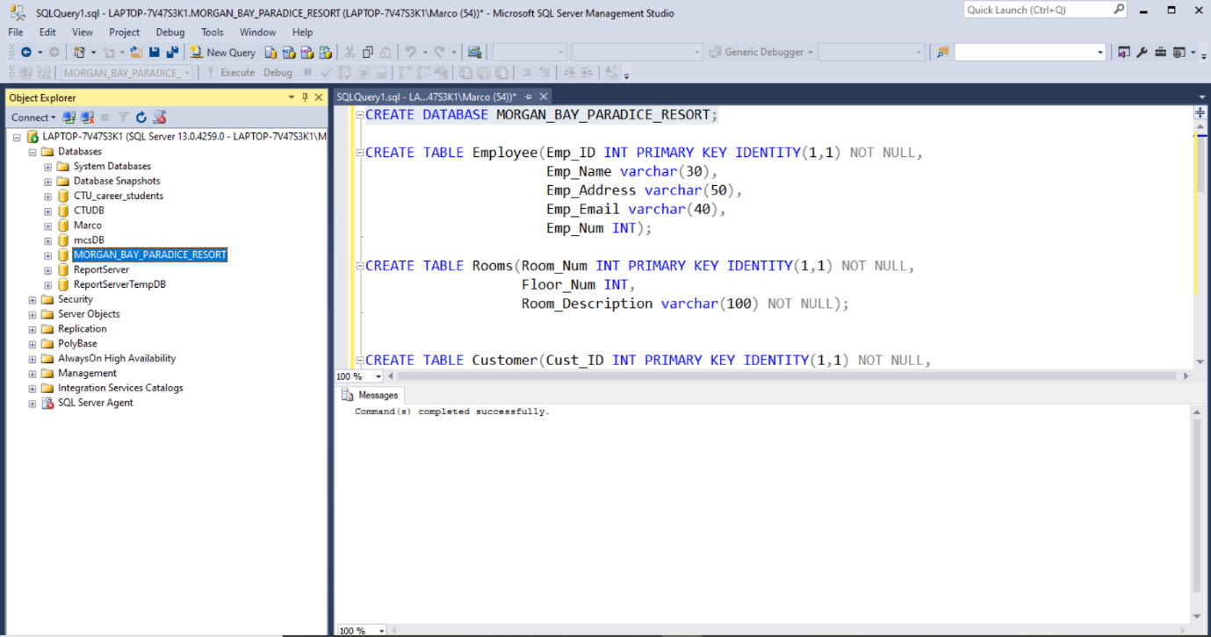Figure

## Tables with attributes created in the database:

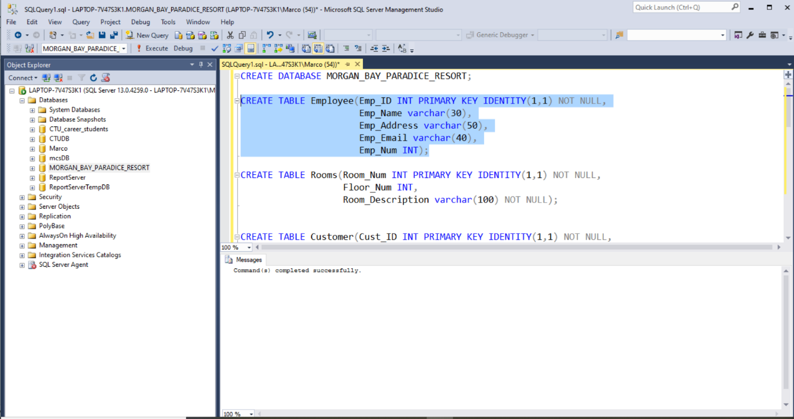Figure

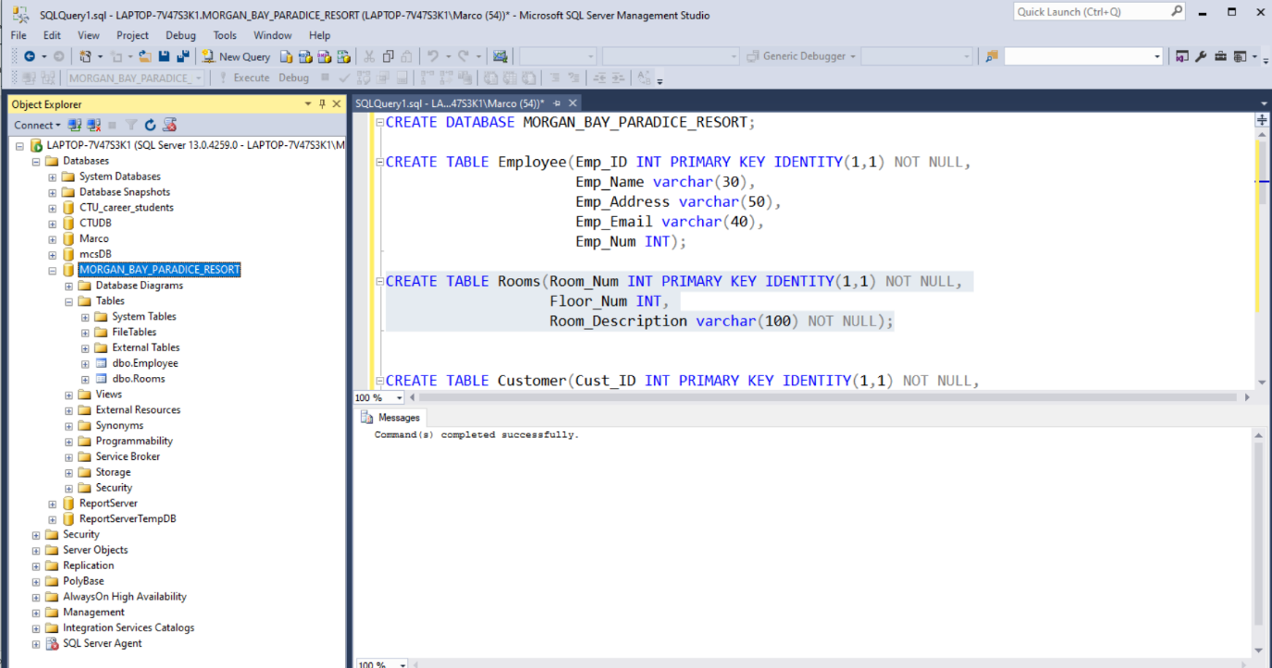Figure

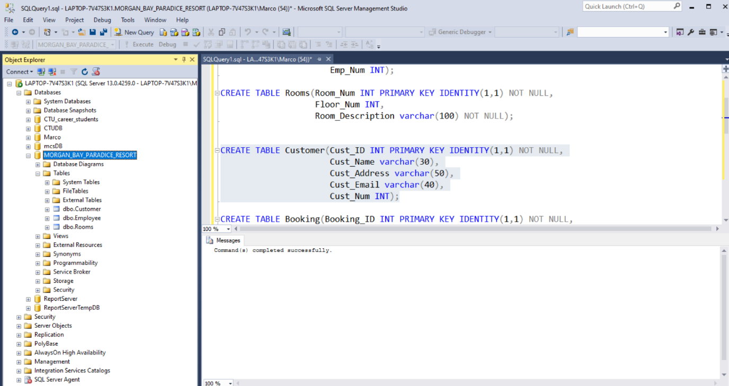Figure

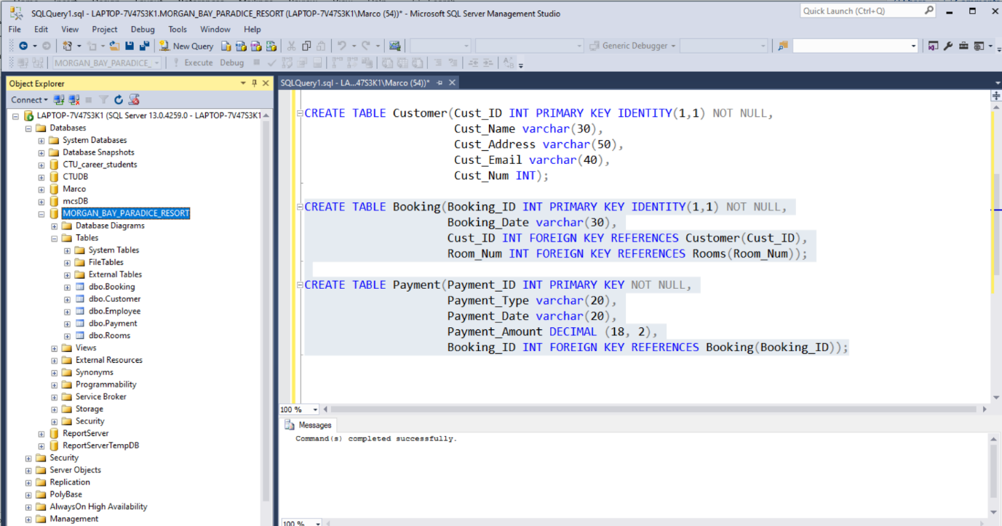Figure

## Connect.php code provided:

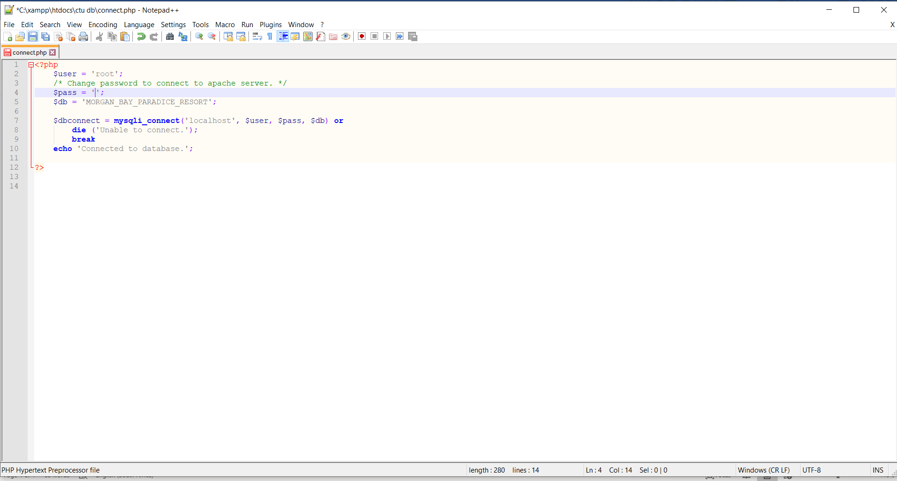Figure

# Group:

Muhammed Khan: 6011

Limi Madelisa: 5970

Masego Ramanathan: 5980

Marco van der Merwe: 4861

Nadia Noack: 5972

# Conclusion:

In conclusion, we have created a database within the SQL management studio for the MCSD students to use when connecting their website to a database. They will make use of the above database as required.

# Reference:

* <https://www.w3schools.com/php/php_mysql_intro.asp>